It’s Your Move…
I gave you life,
but cannot live it for you
I can teach you things,
but I cannot make you learn
I can take you to church,
but I cannot make you believe
I can teach you right from wrong,
But I can’t always be there to decide for you
I can buy you beautiful clothes,
But I cannot make you lovely inside
I can teach you to share,
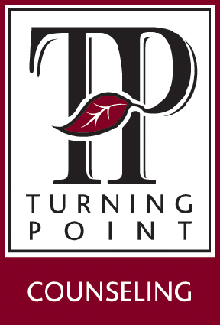
But I cannot make you unselfish
951 W. Imperial Hwy, Ste. 150
Brea, CA 92835
TurningPointCounseling.org
800-998-6329 (99-TODAY)

With over 40 locations in Southern California to serve you with Christian Counseling
Dr. Peter Robbins
Marriage Psychologist

I can teach you about sex,
But I cannot keep you pure
I can tell you about the facts of life,
But I can’t build your reputation
I can warn you about drugs,
But I can’t keep you from using them
I can teach you kindness,
But I cannot force you to be gracious
I can teach you about Jesus,
But I cannot make Him your Savior
I can teach you to obey,
But I cannot make Jesus your Lord

